Early Models of the Atom

Learning Goal 11: I can draw and describe early models of the atom and explain the experimental results that led to their development.

- Ask your teacher for the handout titled “Early Models of the Atom”.

Part 1: Dalton’s Model of the Atom

The “Billiard Ball” Model

- Look at the handout titled “Early Models of the Atom”.

This handout illustrates four early models of the atom using three
different elements.

- Examine the examples of Dalton’s model of the atom.

- What are you able to learn about atoms from the illustrations of
Dalton’s model of the atom?

- Dalton also developed several postulates about the existence and
behavior of atoms.

These postulates laid the groundwork for the development of modern
atomic theory.

  - The table below describes and illustrates four postulates of
Dalton’s atomic theory. You will need to memorize these
postulates.
- For each postulate, create a tool to help you remember it.

Your tool can be a song, a poem, a mnemonic, or any other device
that you think will help you to remember the postulate.

If you choose to create a picture, you must create a different
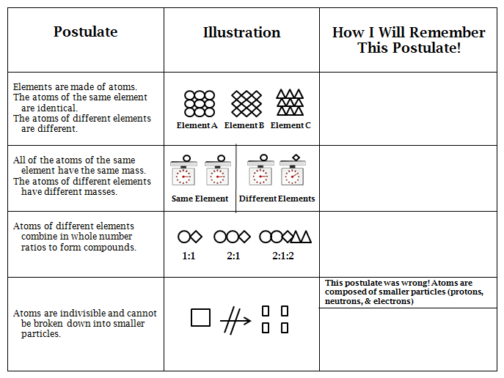
picture than the one already shown

Part 2: Thomson’s Model of the Atom

Negatively charged electrons
Diffuse positive charge

The “Plum Pudding” Model
- Return to the handout titled “Early Models of the Atom”.

- Compare the examples of Thomson’s model of the atom to the
examples of Dalton’s model of the atom.

- Identify two things that Thomson added to the model of the
atom.

Thomson’s Experiment

- In order to understand Thomson’s experiment, your teacher will
perform the following demo:

- Go to a sink and turn on the water so that it is falling in a gentle
stream. Water particles have a positive side and a negative side.
Water Particle

- Rub a latex balloon on your hair for several seconds – this creates
negative charges on the balloon.
Negative Charges

- Hypothesize! What do you think will happen when you put the
negatively charged balloon next to the stream of water?

- Place the balloon next to the stream of water, but don’t let it touch
the water.

- Describe what happened in words and pictures.

- Why do you think this happened? Develop an explanation for what you
observed. (Hint! Think about the charges!)

- Thomson performed an experiment using a cathode ray tube.

A cathode ray is composed of small parts of atoms.

- Normally a cathode ray will travel in a straight line when generated
in a vacuum tube as show below. (A vacuum tube is a tube
without any air in it.)
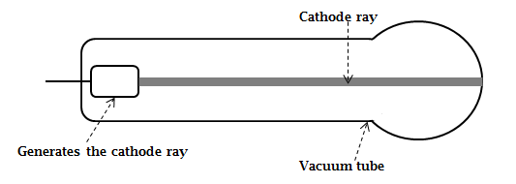

- When positively and negatively charged plates are applied to the
cathode ray, the ray bends as shown below.

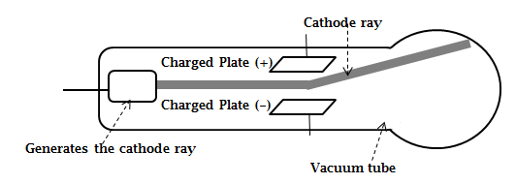

- Why do you think the cathode ray bent towards the positive plate?
(Hint! Think about what happened when you placed the charged
balloon next to the water.)

- How do you think the results of this experiment led Thomson to
conclude that the atom contained negatively charged particles
(electrons)?

- Thomson also concluded that if there were negatively charged
particles in the atom, there must be positive charge in the atom as
well.

What do you think would happen if there were ONLY negatively
charged particles in the atom? (Hint! Think about what happens
when you put negatively charged things together.)

Part 3: Rutherford’s Model of the Atom

Dense positive charge
(nucleus of the atom,
containing protons)
Negatively charged electrons

The “Planetary” Model

- Return to the handout titled “Early Models of the Atom”.

- Compare the examples of Rutherford’s model of the atom to the
examples of Thomson’s model of the atom.

- Identify the main change that Rutherford made to the model of
the atom.

- Rutherford performed an experiment using positively charged
particles and a piece of gold foil.

Gold foil is like aluminum foil except that it is composed of gold atoms
instead of aluminum atoms.

- Rutherford shot the positively charged particles through the gold
foil and recorded where they ended up.

Stream of pos. charged
particles (+)

Gold Foil

Generates pos. charged
particles (+)

Records where particles end up
- Open the envelope labeled “Rutherford Card Set”.

Each card in this set shows the path of one of the positively
charged particles through the gold foil.

- Shuffle the cards and place them face down in a pile.

- Draw one card at a time and look at the path of the particle
on the card. Draw the particle’s path on the picture below.

If more than one particle travels along the same path, make
the line for that path thicker each time.

- What path do the particles take most often when they hit the
foil?

- What happens to the particles on rare occasions?

- The results of this experiment led Rutherford to conclude
that atoms contain a small, dense, positively charged area
surrounded by mostly empty space and extremely tiny,
negatively charged particles.

How do you think the results of this experiment led
Rutherford to these conclusions?

Part 4: Chadwick’s Model of the Atom

Dense positive charge
(nucleus of the atom,
containing protons AND
neutrons)
Negatively charged electrons

The “Planetary Model” – Revised

- Return to the handout titled “Early Models of the Atom”.

- Compare the examples of Chadwick’s model of the atom to the
examples of Rutherford’s model of the atom.

- Identify the main change that Chadwick made to the model of
the atom.

- Chadwick performed experiments on the radiation of beryllium
atoms.

As the result of his experiments, Chadwick was able to confirm the
existence of neutral particles in the nucleus of the atom (neutrons).

- Draw the Dalton, Thomson, Rutherford , and Chadwick Models for
each of the following atoms.

Use the following symbols to represent the subatomic particles in your
drawings.

negatively charged subatomic particle (electron)

positively charged subatomic particle (proton)

neutral subatomic particle (neutron)

diffuse positive charge

dense positive charge
Beryllium (Be) – 4 negative subatomic particles (electrons)
4 positive subatomic particles (protons)
5 neutral subatomic particles (neutrons)

Dalton’s Model Thomson’s Model Rutherford’s Model Chadwick’s Model

Oxygen (O) – 8 negative subatomic particles (electrons)
8 positive subatomic particles (protons)
8 neutral subatomic particles (neutrons)

Dalton’s Model Thomson’s Model Rutherford’s Model Chadwick’s Model

Carbon (C) – 6 negative subatomic particles (electrons)
6 positive subatomic particles (protons)
6 neutral subatomic particles (neutrons)

Dalton’s Model Thomson’s Model Rutherford’s Model Chadwick’s Model

Early Models of the Atom
Study Sheet

Dalton’s Model Thomson’s Model

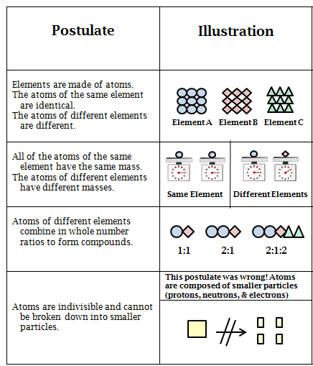
The “Billiard Ball” Model The “Plum Pudding” Model

The Experiment: Cathode Ray Tube Experiment
Led to the discovery of negatively charged particles (electrons). Implied
the existence of positive charge in the atom.

Rutherford’s Model

The “Planetary” Model

The Experiment: Gold Foil Experiment
Led to the discovery of a small, dense, positively charged area at the center
of the nucleus (later determined to be protons in the nucleus). Implied that
most of the atom was empty space and that the negatively charged
particles (electrons) were extremely tiny.

Chadwick’s Model

The Planetary Model – Revised

The Experiment: Beryllium Radiation
Led to the discovery of small neutral particles in the nucleus (neutrons)

