Practice Quiz
Learning Goals 1-4

Learning Goal 1: I can compare and contrast the particle structure and physical properties of solids, liquids, and gases.

Define the following terms. (Criteria 1)

- Matter: Anything with mass and volume

- Particles: Small pieces of matter

- Attractive Force: Force that holds particles together

Describe the arrangement of particles in solids, liquids, and gases. (Criteria 2)

Solids: particles are close together

Liquids: particles a further apart and slide by one another

Gases: particles are very far apart

Determine whether each of the following statements describe a solid, liquid, or gas. (Criteria 3)

- Particles have high energy and are easily compressible gas
- Particles vibrate in place and have a strong attractive force solid
- The volume of the substance changes when you change container size gas
- Particles slide by one another and partially take the shape of the container liquid
- Particles do not take the shape of the container solid

Learning Goal 2: I can describe the differences between intensive physical properties, extensive physical properties, and chemical properties of matter.

Differentiate between the following terms. Use the word “particles” in your answers(Criteria 1 and 3))

- Physical property vs chemical property
Physical Property: particles don’t change when the property is observed
Chemical Property: particles do change when the property is observed

- Extensive property vs intensive property
Intensive Property: particles don’t change when the amount changes
Extensive Property: particles do change when the amount changes

Identify the following properties as intensive physical, extensive physical, or chemical. (Criteria 2)

- Density intensive physical
- Mass extensive physical
- Color intensive physical
- Flammability chemical
- Reactivity chemical
- Melting point intensive physical
Learning Goal 3: I can describe the differences between physical and chemical changes of matter.

Define the following terms. (Criteria 1)

- State change: physical changes between solids, liquids, and gases

- Precipitate: a solid that forms from two liquids in a chemical reaction

Identical the following changes as physical changes or chemical changes. (Criteria 2)
- Burning of wood chemical
- Sublimation of a solid to a gas physical
- Dissolving salt in water physical
- Reaction of sodium (Na) and chlorine (Cl) to form salt (NaCl) chemical
- Boiling of water physical

Differentiate between physical and chemical changes. Use the terms “atoms” and “particles” in your answer. (Criteria 3)
Physical Change: The atoms in the particles do not change structure
Chemical Change: The atoms in the particles do change structure

Learning Goal 4: I can classify examples and particle illustrations of matter as pure substance (element), pure substance (compound), mixture (homogeneous), or mixture (heterogeneous).

Answer the following questions. (Criteria 1 and 2)

- How are the atoms in an element particle different from the atoms in a compound particle?
Atoms in an element are identical; atoms in a compound are different

- How are the particles in pure substance different from the particles in a mixture?
Particles in pure substance are identical; particles in mixtures are different

- How are the particles in a homogeneous mixture different from the particle in a heterogeneous mixture?
Particles in homogeneous mixtures are evenly distributed
Particles in heterogeneous mixtures are unevenly distributed

Classify the following illustrations as pure substance (element), pure substance (compound), mixture (homogeneous), or mixture (heterogeneous). (Criteria 3)

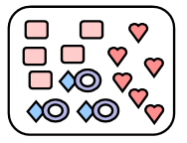
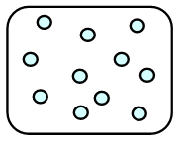
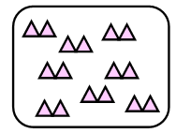

Pure Substance Element Heterogeneous Mixture Pure Substance Element

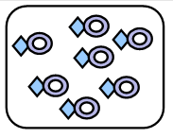
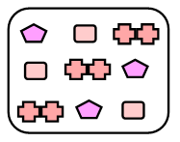

Homogeneous Mixture Pure Substance Compound

