Protons, Electrons, and Neutrons

Learning Goal 12: I can determine the number of protons, neutrons, and electrons in atoms when given atom symbols, illustrations of basic atom models, and/or a periodic table.

Subatomic Particles: particles that compose atoms.

- Protons
- Located in the nucleus
    - Positive charge

- Neutrons
- Located in the nucleus
Vocabulary!
- No charge

- Electrons
- Located in mostly empty space
surrounding the nucleus
- Negative charge
- Very, very tiny

- Open the envelope labeled “Atom Card Set” and tear out the “Atom Data Sheet” on page _______.

This card set contains ten cards:

  - Five of the cards show illustrations of the subatomic particles in
lithium atoms.
  - Five of the cards show illustrations of the subatomic particles in
nitrogen atoms.

The subatomic particles on each card are illustrated as shown below:

Atom Card Key

Nucleus

Neutron (White)
Proton (Red)
Electron (Black)

- Sort the cards into two groups based on whether they illustrate
lithium or nitrogen atoms.

- Count the number of protons, neutrons, and electrons on each card
and record your answers on the “Atom Data Sheet”.

Part 1: Protons

- Use the information that you recorded on the “Atom Data Sheet”
to answer the following questions.

  - Which subatomic particle is present in the same amount in all
of the lithium atoms?

- Which subatomic particle is present in the same amount in all
of the nitrogen atoms?

- What do you think determines the identity of an atom - the
number of protons, the number of neutrons, or the number
of electrons?

- Look at the atom symbol indicated for each atom on the cards and
the “Atom Data Sheet”.

- Which part of the atom symbol do you think indicates the number
of protons?

- Look at the periodic table boxes for lithium and nitrogen.

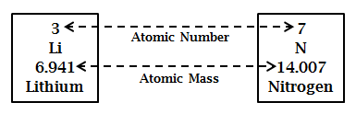

- Which number in the periodic table boxes do you think indicates
the number of protons?

The Atomic Number:

  - is the whole number in the periodic table square.

  - is the bottom, left number in an atom symbol.

  - is always equal to the number of protons.
Vocabulary!

  - is equal to the number of electrons in a neutral
atom. (See Part 2: Electrons.)

  - will tell you the identity of an atom, because
each atom has a different atomic number.

- Ask your teacher for a set of “Proton Task Cards” and get out the
“Task Card Answer Sheet”.

- Answer each of the questions on the Proton Task Cards. Record your
answers on your “Task Card Answer Sheet”.

Part 2: Electrons

- Look at the handout titled “Atoms and Charge”.

This handout illustrates the number of protons and electrons that
can be found in lithium and nitrogen atoms.

- Notice that:
  - each proton adds one positive (+) charge to the atom.

  - each electron adds one negative (-) charge to the atom.

  - there are two versions of each atom, neutral and ion

Neutral Atoms

- Look at the neutral lithium and nitrogen atoms on the “Atoms
and Charge” card.

  - What do you notice about the number of protons relative to the
number of electrons in a neutral atom?

- Look at the atom symbols below. They are the atom symbols for
neutral lithium and neutral nitrogen atoms.

⁷₃Li ¹⁴₇N

  - What part of the atom symbol can you use to determine the
number of electrons in a neutral atom? (Hint: Think about your
answer to the previous question and what you just learned about
protons.)

- Look again at the periodic table squares for lithium and nitrogen
shown below.

- Which number do you think indicates the number of electrons
in a neutral atom, the atomic number or the atomic mass?

A neutral atom has the same number of
Vocabulary!
electrons and protons.

The charge of a neutral atom is equal to zero.

Ions

- Return to the handout titled “Atoms and Charge”.

  - Look at the lithium ion on the “Atoms and Charge” card.

  - What happens to the electrons of a neutral lithium atom when it
becomes a lithium ion?

- Look at the atom symbols below. They are the atom symbols for
neutral lithium atoms and lithium ions.

⁷₃Li ⁷₃Li¹⁺

  - What is the difference between the atom symbol for the neutral
lithium atom and the atom symbol for the lithium ion?

  - Why does the lithium ion symbol have a positive charge? (Hint:
Refer back to the “Atoms and Charge” card.)

  - What do you think the small number “1” indicates in the lithium
ion atom symbol? (Hint: Refer back to the “Atoms and Charge”
card.)

- When an ion has a positive charge, it means that the atom has
_________ (less or more) electrons than its neutral form.

Vocabulary!
An ion is an atom with a charge.

An ion with a positive charge is called
a cation.
Vocabulary!

A cation is formed when a neutral atom
loses electrons.

- Return to the handout titled “Atoms and Charge”.

  - Look at the nitrogen ion on the “Atoms and Charge” card.

  - What happens to the electrons of a neutral nitrogen atom when it
becomes a nitrogen ion?

- Look at the atom symbols below. They are the atom symbols for
neutral nitrogen atoms and nitrogen ions.

¹⁴₇N ¹⁴₇N³⁻

  - What is the difference between the atom symbol for the neutral
nitrogen atom and the atom symbol for the nitrogen ion?

  - Why does the nitrogen ion symbol have a negative charge? (Hint:
Refer back to the “Atoms and Charge” card.)

  - What do you think the small number “3” indicates in the nitrogen
ion atom symbol? (Hint: Refer back to the “Atoms and Charge”
card.)

- When an ion has a negative charge, it means that the atom has
_________ (less or more) electrons than its neutral form.

An ion with a negative charge is called
an anion.
Vocabulary!

An anion is formed when a neutral atom
gains electrons.

- Summary: How to determine the number of electrons.

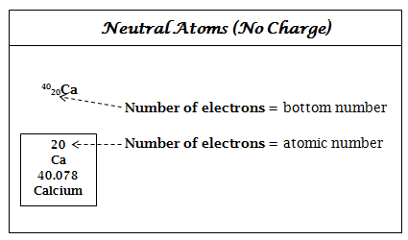

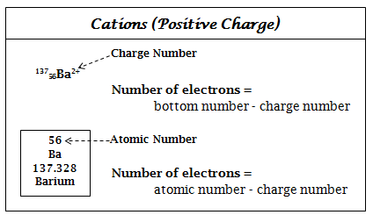

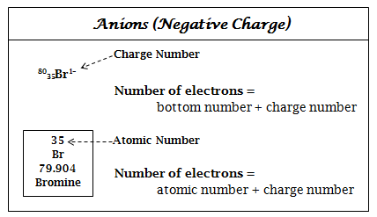

- Ask your teacher for a set of “Electron Task Cards” and get out the
“Task Card Answer Sheet”.

- Answer each of the questions on the Electron Task Cards. Record your
answers on your “Task Card Answer Sheet”.

Part 3: Neutrons

- Return to the information that you recorded on your “Atom Data
Sheet”.

- Look at the three neutral lithium atoms.

  - What are two differences between the three neutral lithium atoms?

- The top number to the left of the atom symbol is called the mass
number.

The mass number is equal to the sum of two of the subatomic particles.

- Use the information on your “Atom Data Sheet” to determine
whether the mass number is equal to: the number of protons plus
electrons, the number of protons plus neutrons, or the number of
neutrons plus electrons.

- How can you determine the number of neutrons in an atom?
(Hint!: Refer back to your last answer and construct a mathematic
equation.)

- How can you use an atom symbol to determine the number of
neutrons in an atom? (Hint: Remember, the top number is
the mass number and the bottom number is the number of
protons.)

- Look again at the periodic squares for lithium and nitrogen below.
The mass numbers for lithium and nitrogen are also shown.

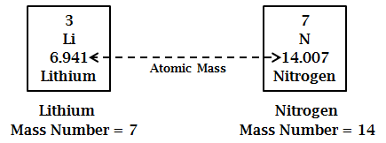

- Compare the atomic mass and mass number for lithium and nitrogen.

- How is the mass number related to the atomic mass?

- How can you use the periodic table to determine the number of
neutrons? (Hint: Remember, the atomic number is equal to the
number of protons and the atomic mass (rounded) is equal to
the mass number.)

The Atomic Mass:
- is equal to the average weighted mass of the
different forms of the same type of atom.

- is usually written as a decimal in the periodic
table.

The Mass Number:
Vocabulary!
- is equal to the mass of a particular form of an
atom.

- is often written as the atomic mass rounded to
a whole number.

- is the top, left number in an atom symbol.

- is equal to the # protons + # neutrons.

- Ask your teacher for a set of “Neutron Task Cards” and get out the
“Task Card Answer Sheet”.

- Answer each of the questions on the Neutron Task Cards. Record your
answers on your “Task Card Answer Sheet”.

- Indicate the location and number of protons, electrons, and
neutrons in each of the atoms shown below. The first one has
been done for you.

p = protons
n = neutrons
e = electrons

Cl

¹⁶₈O²⁻

¹¹₅B
5e

5p, 6n

¹⁹₉F
Mg²⁺
¹⁸₈O

Ba
⁴⁰₂₀Ca²⁺
²₁H¹⁺

Protons, Electrons, and Neutrons
Study Sheet – Page 1

Vocabulary

Subatomic Particle: particles smaller than an atom

Proton: a positively charged subatomic particle located
in the nucleus of an atom

Electron: a tiny, negatively charged subatomic particle
located in mostly empty space around the nucleus of
an atom

Neutron: a subatomic particle with no charge located in
the nucleus of an atom

Neutral Atom: an atom with the same number of protons
and electrons

Ion: an atom that has gained or lost electrons - creates
a positive or negative charge on the atom

Cation: an atom that has LOST one or more electrons -
creates a positive charge on the atom

Anion: an atom that has GAINED one or more electrons –
creates a negative charge on the atom

Atomic Number: indicates the number of protons;
indicates the number of electrons in a neutral atom;
is the whole number in periodic table blocks; is the
bottom, left number in an atom symbol.

Atomic Mass: is the average weighted mass of all of the
forms of a particular type of atom; is the decimal
number in the periodic table

Mass Number: describes the mass of each form of an
of an atom; can be equal to the atomic mass rounded
to a whole number; is used in calculations to determine
determine the number of neutrons; is the top, left
number in an atom symbol

Protons, Electrons, and Neutrons
Study Sheet – Page 2

How to Find the Number of Protons, Electrons, and Neutrons
from an Atom Symbol
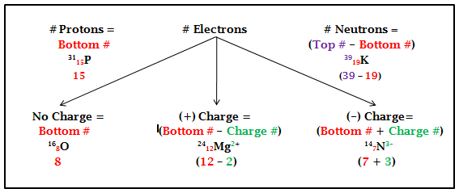

How to Find the Number of Protons, Electrons, and Neutrons
from the Periodic Table
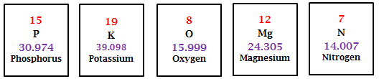

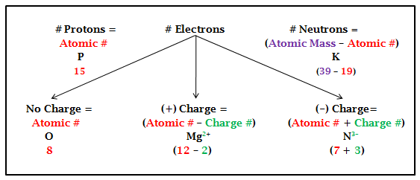
**Round atomic mass numbers to a whole number!
Atoms and Charge

Lithium Atom – Neutral, Li

Li

+
+
+
Proton Charges:

-
-
-
Electron Charges:

Lithium Atom – Ion, Li¹⁺

Li¹⁺

+
+
+
Proton Charges:

-
-
Electron Charges:

Nitrogen Atom – Neutral, N

N

+
+
+
+
+
+
+
Proton Charges:

-
-
-
-
-
-
-
Electron Charges:

Nitrogen Atom – Ion, N³⁻

N³⁻

+
+
+
+
+
+
+
Proton Charges:

-
-
-
-
-
-
-
-
-
-
Electron Charges:
Atom Data Sheet
Symbol | Type of Atom | # Protons | # Electrons | #Neutrons
⁶₃Li | lithium atom - neutral
⁷₃Li | lithium atom - neutral
⁹₃Li | lithium atom - neutral
⁶₃Li¹⁺ | lithium ion (cation)
⁷₃Li ¹⁺ | lithium ion (cation)
¹³₇N | nitrogen atom – neutral
¹⁴₇N | nitrogen atom – neutral
¹⁵₇N | nitrogen atom - neutral
¹⁴₇N³⁻ | nitrogen ion (anion)
¹⁵₇N³⁻ | nitrogen ion (anion)

Task Card Answer Sheet

Proton Task Card Answers

Card Color __________________

1 | 2 | 3 | 4
5 | 6 | 7 | 8

Electron Task Card Answers

Card Color __________________

1 | 2 | 3 | 4
5 | 6 | 7 | 8

Neutron Task Card Answers

Card Color __________________

1 | 2 | 3 | 4
5 | 6 | 7 | 8

